# 通信原理

Ch1. Signals and Spectra（信号和光谱）

Ch2. Formatting and Baseband Modulation（格式化和基带调制）

Ch3. Baseband Demodulation/Detection（基带解调/检测）

Ch4. Bandpass Modulation and Demodulation/Detection

Ch10. Syncronization

## 一：信号和光谱

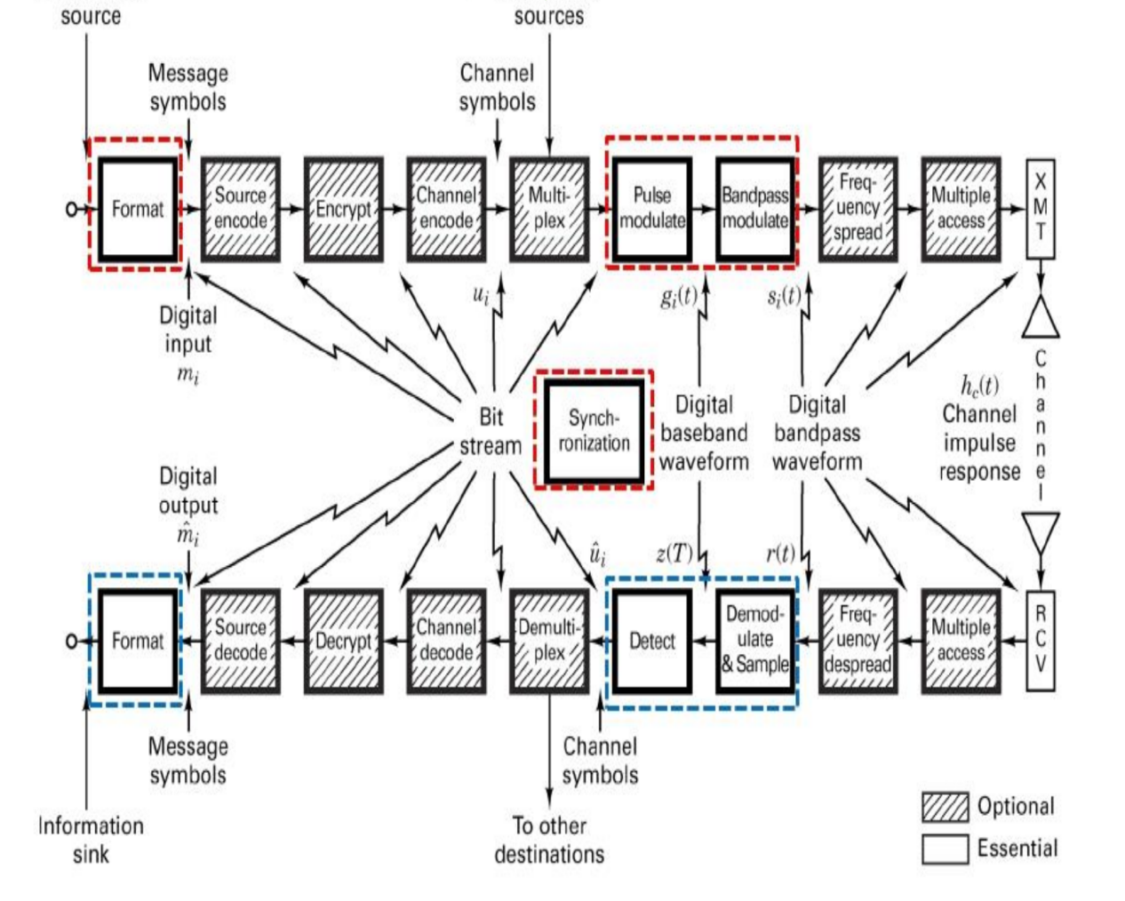

1：Digital Vs Analog Performance Criteria（数字和模拟性能标准）

Two main performance criteria about communication systems？（通信系统的两个主要的性能标准是什么？）

有效性和可靠性

Difference？

模拟信号：传输带宽和信噪比

数字信号：传输速率和错误概率

2：Transmission rate（传输速度） ！！！！这俩到底对应的是哪个

Symbol rate： Rs = Rb / log2M

Data rate： Rb = Rs / log2M

Bandwidth efficiency： η = Rb / B (bits / s / Hz)

3：Probability of error（错误率）

Pb（误码率）： Pe = 错误码元数 / 传输总码元数

Pe（误信率）： Pb = 错误比特数 / 传输总比特数

二进制中：Pb = Pe

4：Information（信息论）

I = log2 1/P(x) = -log2 P(x)

5： energy and power signals（能量和功率信号）

A signal is an energy signal if, and only if, it has nonzero but finite energy for all time（当在所有时间内的能量非零并且有限的时候，这个信号是能量信号）

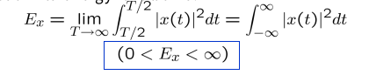

A signal is a power signal if, and only if, it has finite but nonzero power for all time（当在所有时间的功率是非零且有限的，这个信号是功率信号）

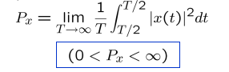

6：General rule: Periodic and random signals are power signals.Signals that are both deterministic and non-periodic are energy signals.（周期信号和随机信号都是功率信号，确定信号和非周期信号都是能量信号）

7：P51 习题1.1

8：How does the plot of a signal’s autocorrelation function reveal its bandwidth occupancy?（信号的自相关函数图如何显示其带宽占用情况?）P29

自相关函数的定义。

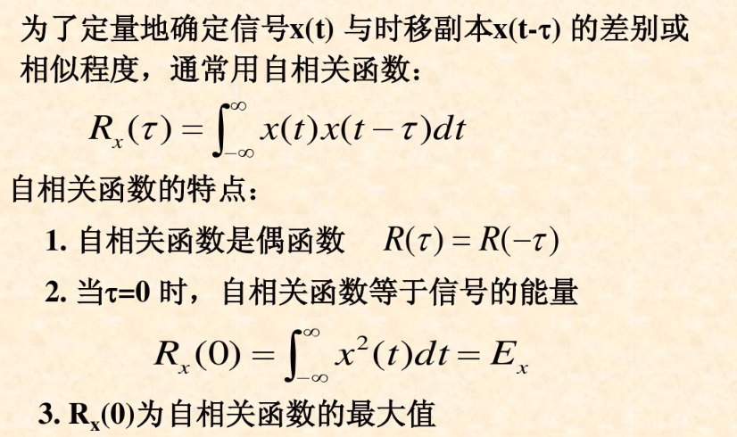

Rx(τ)表示了时间差为τ的两个随机值的统计相关程度，可以得到一些频率信息。

如果τ从0增至某个数值时，Rx(τ)变化缓慢即不尖锐，那么说明信号在两个时间点的采样值在平均意义上近似相等，因此可以预计X(t)的频域主要处在低频段。

如果τ从0增至某个数值的时候，Rx(τ)变化急剧即图形尖锐，那么说明信号在时域变化很快，因此可以预计X(t)的频域主要处在高频段。

9：Noise in communication systems（通信系统中的噪声）

What is the most often used noise model in communication systems?（通信系统中最常用的噪声模型是什么?）

10：AWGN(additive, white, Gaussian, zero-mean)

加性白高斯噪声

噪声分析的两种方法：随机噪声（服从统计规律，用随机函数描述），单（多）脉冲噪声（瞬态分析法）

https://wenku.baidu.com/view/b233bb2de2bd960590c677e5.html?sxts=1550464775909

11：Additive white Gaussian noise means the noise is simply added to the signal, the noise power has a uniform spectral density, and it is a zero-mean Gaussian random process .(白噪声指的是噪声只是增加了信号，噪声功率有一个均匀的光谱密度，它是零均值高斯随机过程)§2.1 Baseband System

§2.2 Formatting Textual Data

§2.3 Messages, Characters, and Symbols

§2.4 Formatting Analog Information

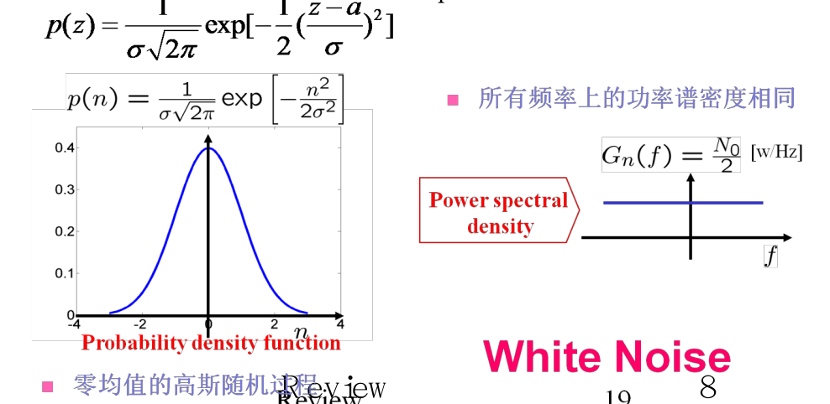

12：If a random process forms the input to a time-invariant linear system, the output will also be a random process.（如果一个随机过程通过线性时不变系统的输出也是一个随机过程）

13：The input power spectral density GX(f) and the output power spectral density GY(f) are related as:（输入功率谱密度GX(f)和输出功率谱密度GY(f)的关系）

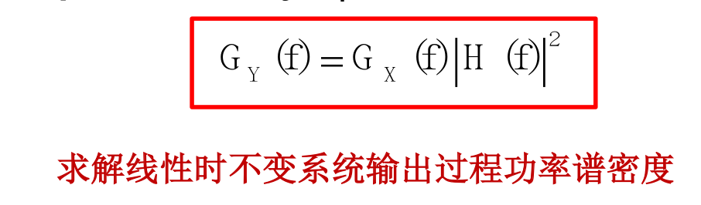

14：What is the required behavior of an ideal transmission line?（一个理想的传输线需要什么）

The overall system response must have a constant magnitude response（幅频响应为常数）

The phase shift must be linear with frequency（相频响应为线性）

15：What mathematical dilemma is the cause for there being several different definitions of bandwidth?（带宽为什么会有几种不同的定义）

The mathematical description of a real signal does not permit the signal to be strictly duration limited and strictly bandlimited. Hence, the mathematical model are abstractions; it is no wonder that there is no single universal definition of bandwidth.

（真实信号的数学描述不允许信号有严格的持续时间限制和严格的带宽限制。因此，数学模型是抽象的。导致带宽没有一个统一的通用定义。）

## 二：Formatting and Baseband Modulation（格式化和基带调制）

§2.1 Baseband System（基带系统）

§2.2 Formatting Textual Data（格式化文本数据）

§2.3 Messages, Characters, and Symbols（消息、字符和符号）

§2.4 Formatting Analog Information（格式模拟信息）

§2.5 Sources Of Corruption（腐败的来源）

§2.6 Pulse Code Modulation（脉冲编码调制）

§2.7 Uniform And Nonuniform Quantization（均匀和非均匀量化）

§2.8 Baseband Modulation（基带调制）

§2.9 Correlative Coding（相关编码）

What are the similarities and differences between the terms “formatting”and “source coding”?（格式编码和源编码有何相似与不同）

Formatting” is a transformation from source information to digital symbols, to insure that the message is compatible with digital symbols. When data compression in addition to formatting is employed, the process is termed “source coding”. Formatting is a special case of soure coding.

（格式”是从源信息到数字符号的转换，以确保消息与数字符号兼容。当使用数据压缩和格式化时，这个过程称为“源编码”。格式化是源代码编码的一种特殊情况）

Formatting（格式化）重点：字符编码，抽样，量化，脉冲编码调制(PCM)

Baseband Signaling（基带信号）重点：脉码调制波形(代码行)，非归零(NRZ)，归零(RZ)，相位编码，多级二进制，多状态脉冲调制，PAM, PPM, PDM

1：Baseband Systems（基带系统）

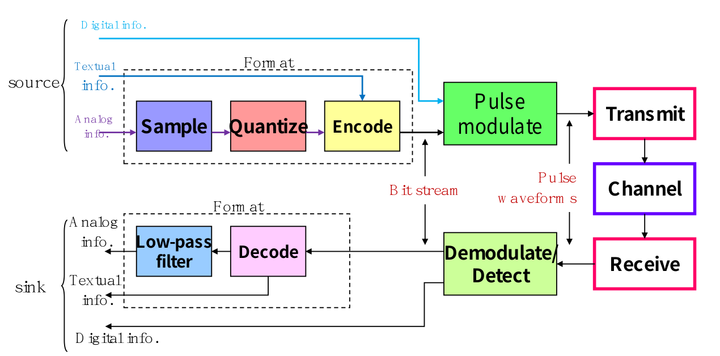

Formatting and transmission of baseband signalsFor baseband channels, compatible waveforms are pulses（对于基带信道基带信号的格式化和传输兼容的波形是脉冲）

2：The Sampling Theorem（采样定理）

Sampling theorem: A bandlimited signal having no spectral components above f m hertz can be determined uniquely by values sampled at uniform intervals of

（采样定理:对于fm赫兹以上无谱分量的带限信号，可以用均匀间隔采样的值唯一确定）

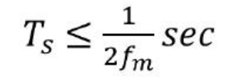

3：Nyquist criterion（奈奎斯特准则）

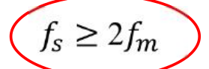

The sampling rate fs = 2fm is also called the Nyquist rate.

（采样速率fs = 2fm也称为奈奎斯特速率）

4：Impulse sampling, natural sampling, sampling & hold

（脉冲采样，自然采样，采样与保持）

5：PCM（脉冲编码调制）

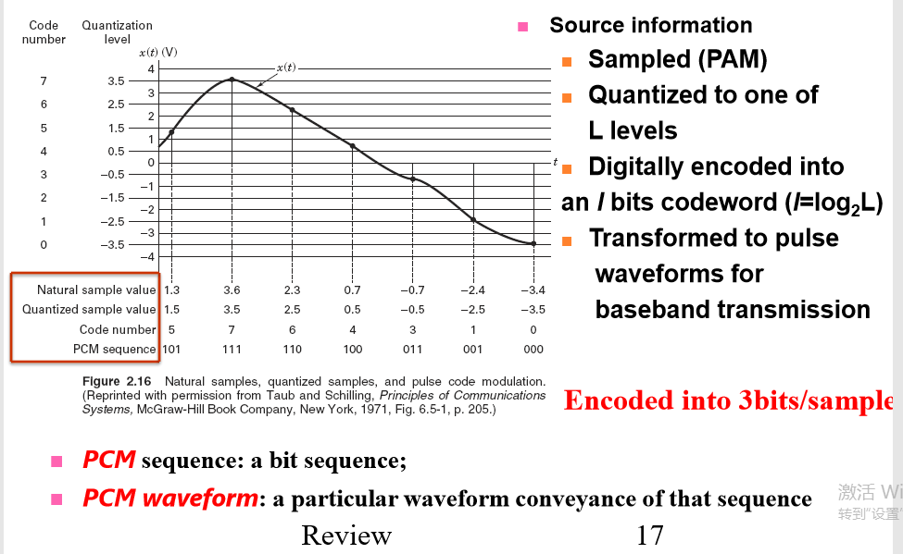

Source information（源信息）

Sampled(PAM)采样（PAM）

Quantized to one of L levels量子化到L级之一

Digitally encoded into an/bits codeword（I=log2L）数字编码成I位码字（I=log2L）

Transfromed to pulse waveforms for baseband transmission转换成基带传输的脉冲波形

PCM sequence: a bit sequence PCM序列：位序列

PCM waveform: a particular waveform conveyance of that sequence PCM波形：该序列的特定波形

6：In using pulse code modulation (PCM) for digitizing analog information, explain how the parameters fidelity, bandwidth, and time delay can be trade off.（在使用脉冲调制PCM数字化模拟信息时，请解释如何权衡参数的保真度、带宽和时延）

For real-time communication: the data rate is increased, and the cost is a grater transmission bandwidth

对实时通信：数据速率提高，代价是传输带宽增大

If delay is permissible: the cost of more quantization levels and greater fidelity can be time delay.

如果允许时延：更多量化级别和更高保真度的代价是时间延迟

7：Signal-to-Noise Ratio for Quantized Pulses（量子化脉冲的信噪比）

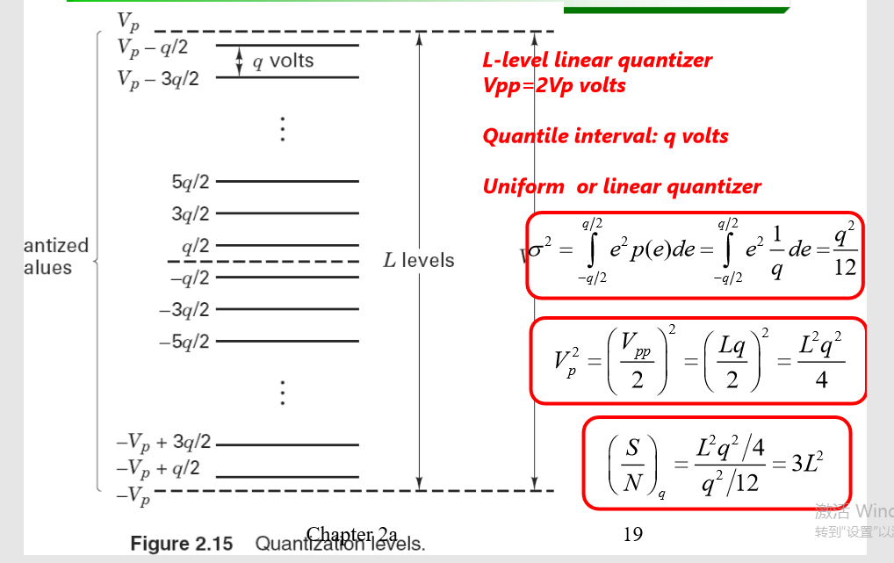

8：PCM Word Size（PCM文字大小）

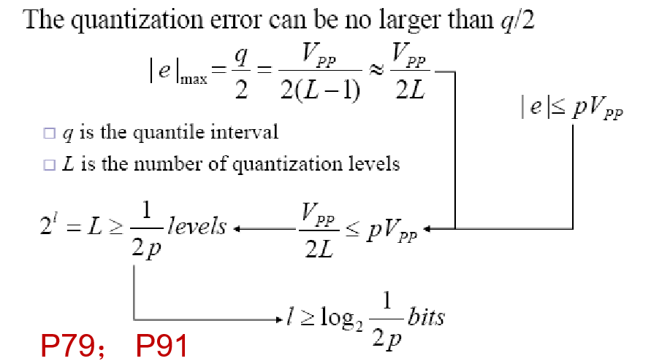

9：task（习题）

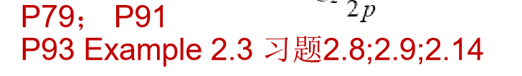

10：Example2.3题目及答案

The information in an analog waveform, with maximum frequency fm = 3 kHz, is to be transmitted over an Mary PAM system, where the number of pulse levels is M= 16. The quantization distortion is specified not to exceed± 1% of the peak-to-peak analog signal.

（最大频率为fm=3khz的模拟波形中的信息将通过Mary PAM系统传输，其中脉冲电平数为M=16，指定的量化失真是模拟信号不超过±1%的峰）

1. What is the minimum number of bits/sample, or bits/PCM word that should be used in digitizing the analog waveform?

（在将模拟波形数字化时应使用的最小位/样本或位/PCM字数目是多少?）

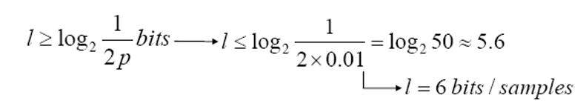

1. What is the minimum required sampling rate, and what is the resulting bit transmission rate?

（所需的最低采样率是多少，产生的比特传输率是多少?）

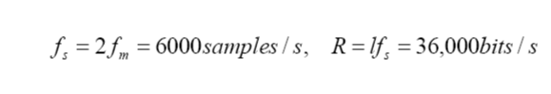

1. What is the PAM pulse or symbol transmission rate?

（PAM脉冲或符号传输速率是多少?）

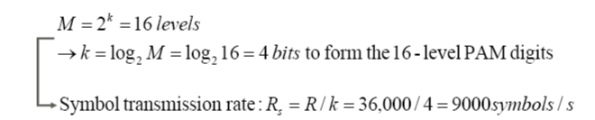

1. If the transmission bandwidth (including filtering) equals 12 kHz, determine the bandwidth efficiency for this system.

（如果传输带宽(包括滤波)等于12khz，则确定该系统的带宽效率。）



11：Nonuniform Quantization（非均匀量化）Why does speech signal need non-uniform quantization?（为什么语音信号需要非均匀量化）

For most voice communications, very low speech volumes predominate;

（对大多数语音通信而言，比较低的语音占主导地位）

If use uniform quantization, the quantization error will be big and the SNR is worse.

（如果采用均匀量化，量化误差较大，信噪比较差。）

Nonuniform quantization can provide fine quantization of the weak signals and coarse quantization of the strong signals, Quantization noise can be made proportional to signal size. The effect is to improve the overall SNR

（非均匀量化可以对弱信号进行精细量化，对强信号进行粗量化，量化噪声与信号大小成正比。其效果是提高整体信噪比）

12：Correlative Coding（相关编码）

In 1963, Adam Lender showed that it is possible to transmit 2W symbols/s with zero ISI, using the minimum bandwidth of W hertz, without infinitely sharp filters. He used a technique called duobinary signaling, also referred to as correlative coding and partial response signaling.

（1963年，Adam Lender证明了在没有无极锐滤波器的情况下，使用W赫兹的最小带宽以零ISI传输2W符号/秒是可能的。他使用了一种叫做双二进制信号的技术，也称为相关编码和部分响应信号。）

The basic idea: introduce some controlled amount of ISI into the Data stream rather than trying to eliminate it completely.

（基本思想是:在数据流中引入一定数量的ISI，而不是试图完全消除它。）

13：Duobinary Signaling（双进制的信号）

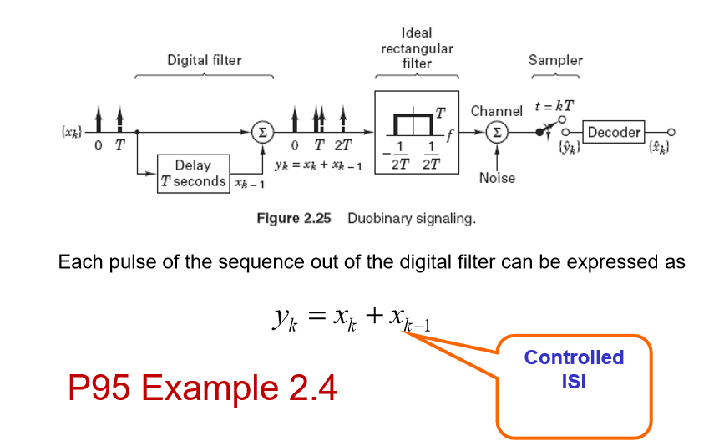

14：Example2.4

？？？？？？？？？？？？？？？

15：Duobinary Decoding（双进制的解码）

If the binary digit xk is equal to±1,then yk has one of three possible value:+2,0 or -2

（如果二进制数字xk等于±1,然后即有三种可能的值:0或2 + 2,）

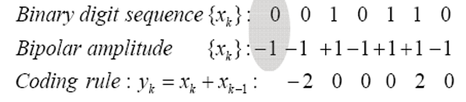

Binary digit sequence（二进制数字序列）

Bipolar amplitude（双相振幅）

Coding rule（编码规则）

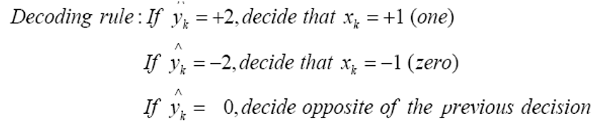

Decoding rule（解码规则）

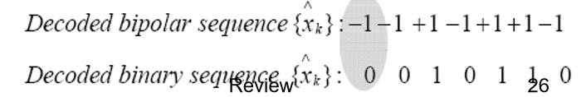

Decoded bipolar sequence（双解码序列）

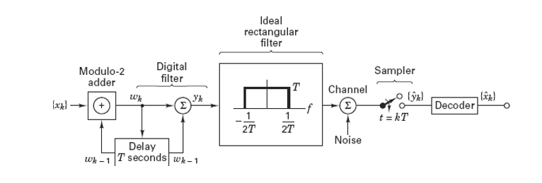

Precoding is accomplished by first differentially encoding the {xk} binary sequence into a new {wk} binary sequence:

（预编码是先将{xk}二进制序列差分编码为一个新的{wk}二进制序列:）

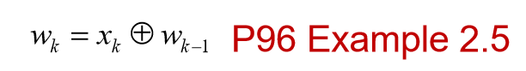

16：Example 2.5

？？？？？？？？？？？？？

17：Duobinary Precoding（双进制预编码）

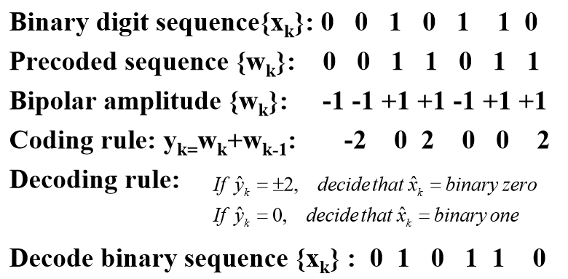

## 二：Baseband demodulation/Detection（基带解调/检测）

3.1 Signals and Noise （信号与噪声）

3.2 Detection of Binary Signals in Gaussian Noise （高斯噪声中的二进制信号的检测）

3.3 Intersymbol Interference （码间干扰）

3.4 Equalization （均衡）

1：Error-Performance Degradation（误差性能的下降）

Two primary causes for error-performance degradation（误差性能下降的两个原因）

Effect of filtering at the transmitter, channel, and receiver-(ISI)–nonideal system transfer function（在发射机、信道和接收机上的滤波效果（ISI）-非理想系统传递函数）

Electrical noise and interference -Loss of SNR（电噪声和干扰损失的信噪比）

2：Two Types of Error-Performance Degradation（两种误差性能下降的类型）

More Eb/N0 would have to be provided in order to meet the required bit-error probability（为达到相同的误比特率，需 要提供更多的Eb/N0）

When distorting is caused by ISI, more Eb/N0 may not help the ISI problem.（增大Eb/N0并不能解决码间串扰问题）

The cure is found in a technique called equalization（解决方案：均衡技术）

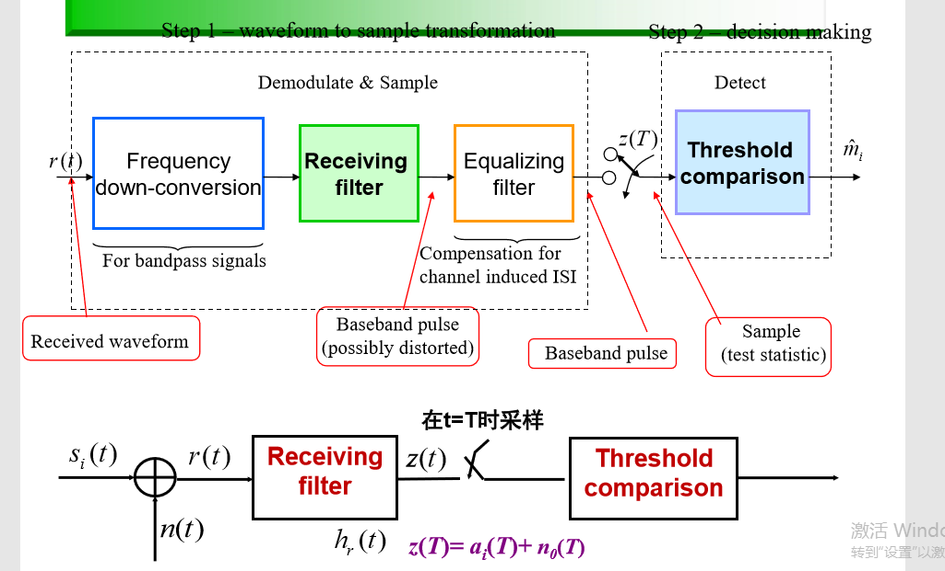

3：The Matched Filter（匹配滤波器）

A matched filter is a linear filter designed to provide the maximum signal-to-noise power ratio at its output for a given transmitted symbol waveform.（匹配滤波器是一种线性滤波器，其设计目的是在给定的传输符号波形的输出端提供最大的信噪比。）

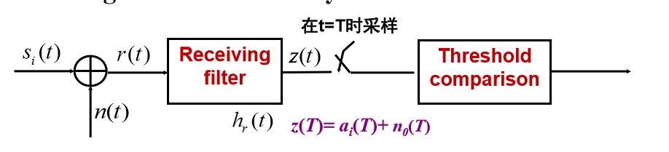

variance of the output noise (average noise power)（输出噪声方差(平均噪声功率)）

The ratio of the instantaneous signal power to average noise power, (S/N)T, at time t = T, out of the sampler in step 1, is（从步骤1中的采样器中取出，T = T时瞬时信号功率与平均噪声功率之比(S/N)T，是）

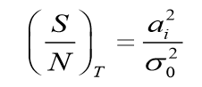

4：Correlation Realization of Matched Filter（匹配滤波器的相关性）

Matched filters basic property（匹配滤波器的基本属性）

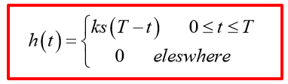

Impulse response of the filter : Delayed version of the mirror (rotated on the t = 0 axis) of the signal waveform（滤波器的脉冲响应:信号波形反射镜的延迟版本(在t = 0轴上旋转)）

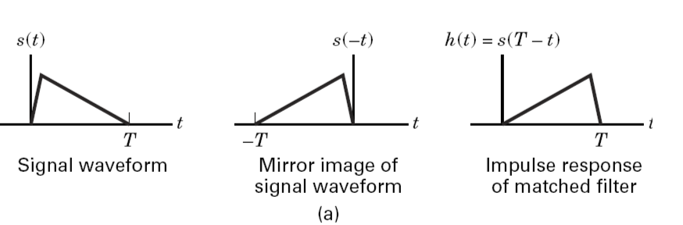

Output of a matched filter（匹配滤波器的输出）

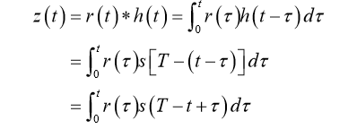

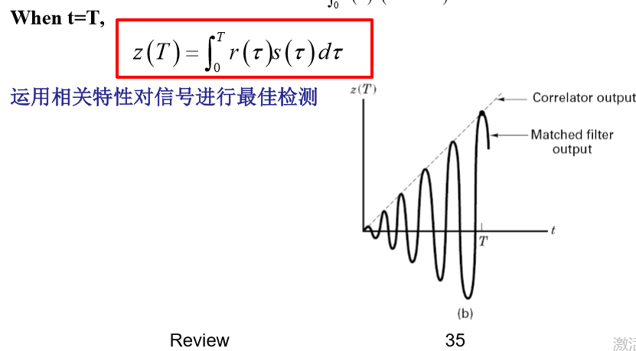

5：What the difference between the MF filter and the correlator?（MF滤波器和相关器有什么区别）

The mathematical operation of a matched filter (MF) is convolution; a signal is convolved with the impulse response of a filter.（匹配滤波器(MF)的数学运算为卷积，信号与滤波器的脉冲响应卷积。）

The mathematical operation of a correlator is correlation; a signal is correlated with a replica of itself.（相关器的数学运算为相关,一个信号与它自身的一个复制品相关联。)

“matched filter” is often used synonymously with “correlator.” （“匹配过滤器”通常与“相关器”同义使用。）

convolution in the MF with a time-reversed function results in a second time-reversal, making the output (at the end of a symbol time) appear to be the result of a signal that has been correlated with its replica. （MF中与时间反转函数的卷积会导致第二次时间反转，使得输出(在符号时间的末尾)看起来像是与它的副本相关的信号的结果。）

It is important to note that the correlator output and the matched filter output are the same only at time t= T.（需要注意的是，相关器输出和匹配的过滤器输出只在t= t时相同。）